Final Presentations: The Official Report

**Index:**

Question1………….………….………….………….…………… 3

Question2………….………….………….………….…………… 5

Question3………….………….………….………….…………… 6

Business Insights…………….…………….…………….………. 7

Unexpected Findings…………….………….…………….…………… 9

As we have mentioned that our dataset is regarding vehicle collisions, we wanted to know how the accidents are happening, the cause of the accident and many other factors. For this, we have gone through some visualizations to get insights for this data.

**1. Chart 1:**

# 

# 

* For this visualization, we have used bar chart.
* Initially we have created parameters for dimension and measure.
* Then we have dragged and dropped parameters to row and column.
* Our question was to know what the contributing factor for the incidents is.
* For this we have used contributing factor vehicle as dimension and Total incidents as a Measure.
* After going through the results, we understood that in most of the cases the contributing factor was unspecified.
* The other reasons that more accidents were Turning improperly, Traffic control disregarded and backing unsafely.
* This drives to our next question which area have recorded more incidents.

# 

# 

**2. Chart 2:**

* To know which location has recorded more incidents, we have used map.

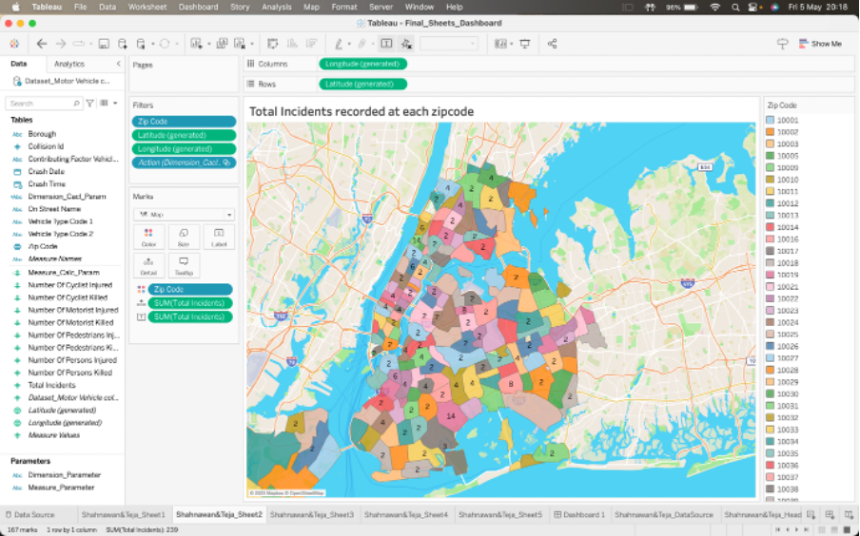

* We have dragged longitude and latitude to column and row.
* Dragged zip code to color to specify the areas based on colors and then dragged total incidents to label and detail.
* The results shows that zip code ‘11236’, ‘10031’has recorded more incidents.
* People who are residing in the surroundings of those zip codes must be more cautious to reduce the number of accidents.
* Our next question was to know how many deaths are recorded in the past 7 years.

**3. Chart 3:**

* For this visualization, we have used line chart.

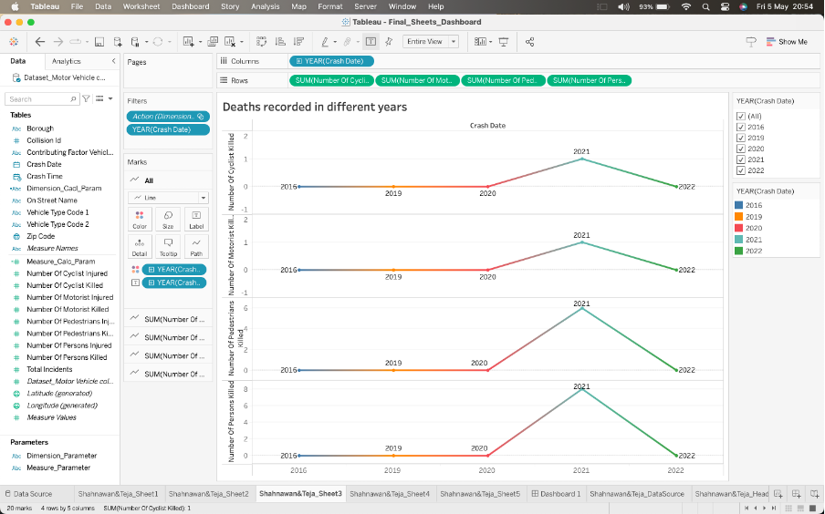

* We have used crash date and number of deaths in each type to get the results.
* As we can see 2021 has a spike but in other years there is flat line.
* This means that 2021 has recorded more number of deaths and that years have not recorded that many deaths.
* We have also used a filter to know how many deaths took place in a specific year in each type.

**Business Insights:**

Following are the significant insights and understandings from the analysis of data on vehicle collisions:

* The major contributing factors for the collisions to happen is because of ‘Failure to yield the right-of-way’ & ‘Driver Inattention’.
* ‘Broad way’ Street has reported the most number of incidents overall. This suggests that more traffic awareness is needed in that area, and it is the responsibility of each individual to carefully and diligently follow all traffic laws.
* Sedans and Sports Utility vehicles (SUV) are the major types of vehicles that have been involved in either of the incidents (accident or injury).
* The locality with the postal code '11236' has documented the greatest number of incidents, with a total of 14 incidents, surpassing all other areas within the city.
* The mortality rate had a considerable increase in 2021, which was then followed by a significant decrease in 2022.
* Also, per analysis, at around 12 pm-6 pm, collisions are most probable to happen. This implies that a driver's weariness and attention may be a problem.

I’d recommend the following measures to take up for the Traffic department:

* Making investments towards infrastructure enhancements, such as road widening, additional lighting, and more evident advertisement, can help improve traffic flow and relieve congestion.
* There are incidents reported with ‘DUI’ reasons. It is the responsibility of the government to impose stricter laws and penalties when drivers are discovered to be operating a vehicle under the influence.
* An increase in the number of traffic awareness programs for promoting safe driving practices.

# 

**Unexpected Findings:**

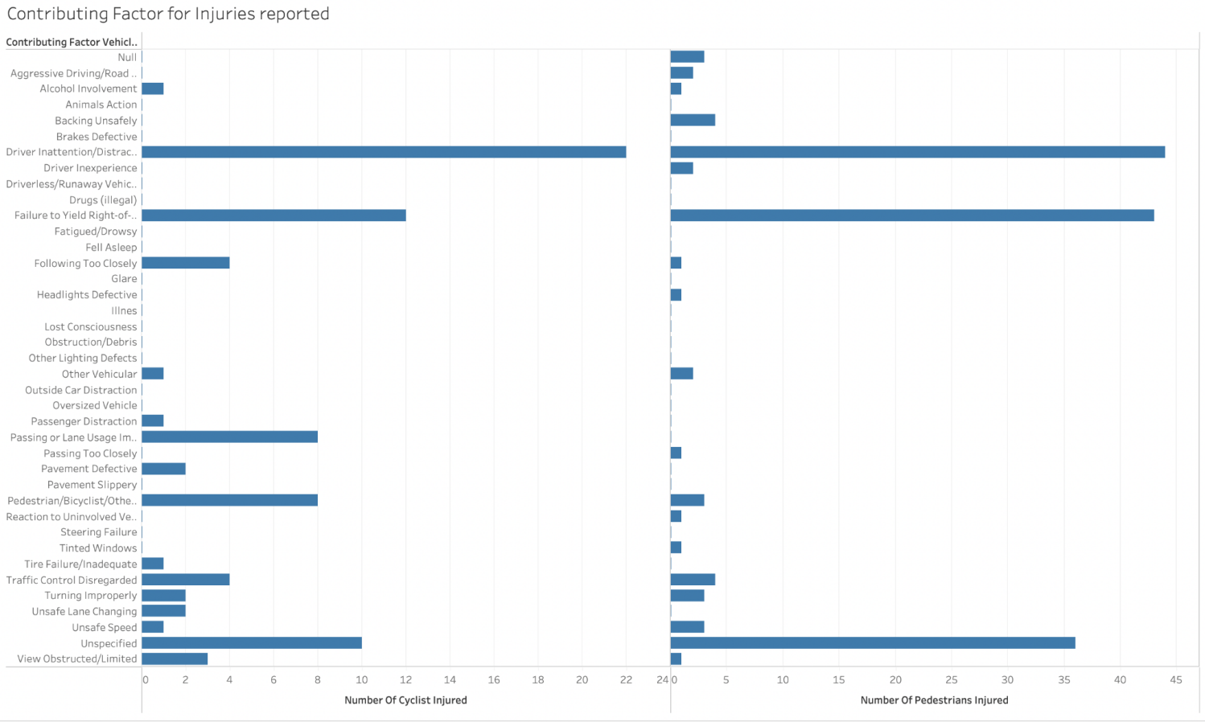

* From further analysis of the data, we found that there are many Injuries reported due to different Contributing Factors. ‘Driving inattention/ Distraction’ has been a major contributor to injuring Cyclists and pedestrians.
* A total of 22 cyclists and approximately 45 individuals have been injured. The second-most contributing factor was ‘Failure to Yield Right-of-way’ in both cases.
* Although there are ‘unspecified’ reasons which caused the injury for an individual the count is higher for cyclists and Pedestrians, accounting for 10 and 37 approximately.